**Topic:** BDD - Cucumber with Ruby

**Date:** 07-01-2017

**BDD (Behaviour Driven Development):**

* Written by stakeholders and Non-Technical people
* They are written for acceptance testing to check the behaviour of the application
* Design High-level Scenarios

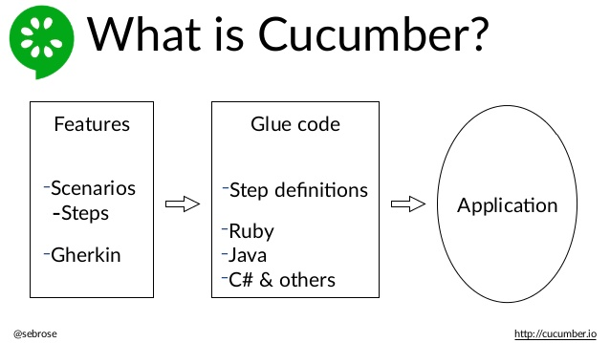

**Writing test cases in BDD format:**

1. Initially install Ruby Installer - > install Development kit for ruby (to import all the gems- use bundler for complete installation of gems)
2. Now, set a workspace for your cucumber project and then create feature file in features folder with **“.feature”** extension and write the code. For example

LoginFunctionality.feature

Feature: Verify LoginFunctionality

Scenario: Login with valid credentials

Given User is on Login page

When user enters username "Sowmya"

And user enters password "Sowmya1234"

And user enters submit button

Then user logins successfully

1. After that open command prompt and execute the cucumber - C:\sowmya\CucumberProjects>cucumber Then you will get an output like

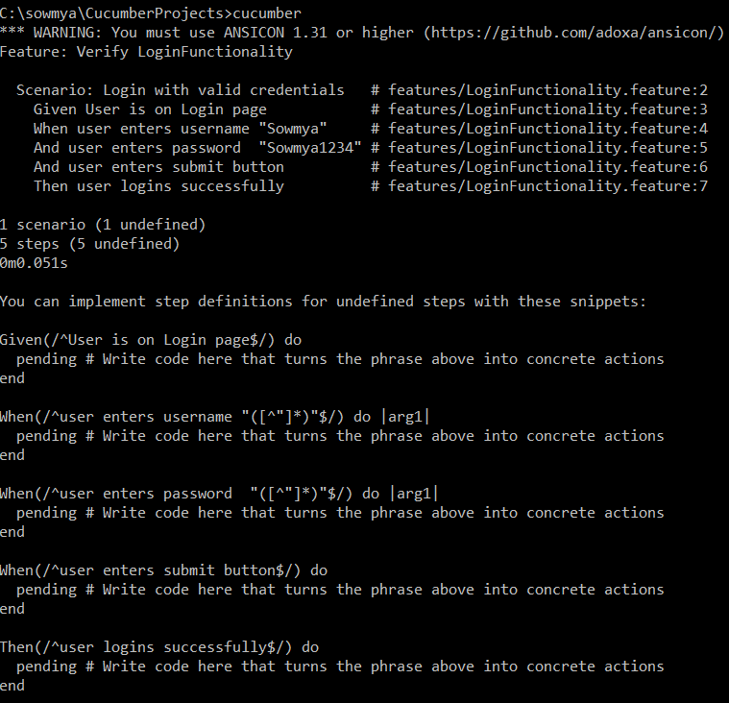

Next, Inorder to execute the acceptance tests which are written in the feature file we have to create step define file in step_definitions folder with “.rb” extension and perform the necessary actions as shown below

StepFile.rb

Given(/^User is on Login page$/) do

puts "User is on Login page"

end

When(/^user enters username "([^"]*)"$/) do |arg1|

puts "user name is " + arg1

end

When(/^user enters password "([^"]*)"$/) do |arg1|

puts "user password is " + arg1

end

When(/^user enters submit button$/) do

puts "user enters submit button"

end

Then(/^user logins successfully$/) do

puts "user logins successfully"

end

Then, again we have to run like C:\sowmya\CucumberProjects>cucumber and now the output will be:

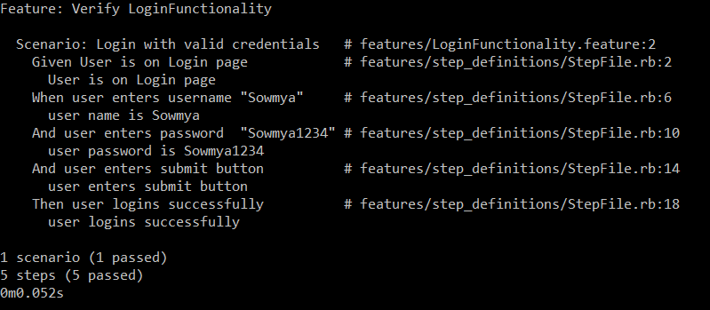

This way we can execute the test case but instead of writing something in the puts field, we have to implement the actual code in any language depending on the tool which we have taken